Wood Stack – Where is the Limit?

Discovering the Harmonic Series

Aron Brunner, Johann Rubatscher

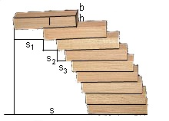

Intention

The question on how far equal wooden cuboids (e.g. dominoes, CD-covers) with the dimensions l, b, and h in a stack can be moved without the stack collapsing has been asked for centuries. The maximal overhang s of the cuboid on top should be discovered here. New developments can be found in the bibliography.

https://de.wikipedia.org/wiki/Harmonische_Reihe

Background of Subject Matter

A stack of cuboids does not collapse if the foot of the common centre of mass of the cuboids does not leave the cuboid below. The maximal shift distance s can be discovered by finding the centre of mass which is just barely located on the surface of the cuboid below. Through adding new cuboids, s can be described through the series:
$l/2+l/4+l/6+l/8+l/10+l/12+l/14+…$,

division by l/2 leads to:

$$l/2 ⋅ \left(1+\frac{1}{2}+\frac{1}{3}+\frac{1}{4}+\frac{1}{5}+\frac{1}{6}+\frac{1}{7}+…\right)$$

The brackets contain the harmonic series, which does not converge. Thus, adding more cuboids leads to a larger shift distance.

Working out the Results

The first cuboid on top can be shifted by $s_{1}=l/2$ as then the centre of mass rests over the edge of the cuboid below. Two cuboids together can be shifted by $s_{2}=l/4$ as due to symmetry, the centre of mass is in the middle of the two independent centres of mass. The shift distance for three cuboids is best solved with an equation. The common centre of mass is located directly above the edge of the fourth cuboid below. Thus, the mass-share of the three cuboids and therefore of the individual cuboids left of the centre of mass equal those on the right. Be x the location of the centre of mass in relation to the left edge of the third. As a result, x equals${ s}_{3}$. As the cuboids are shifted longitudinally, the lengths replace the masses:

Total of individual masses left $=$ Total of individual masses right
Total of individual lengths left $=$ Total of individual lengths right
$x+(x+l/4)+(x+l/4+l/2)$ $=$ $(l-x)+(l-x-l/4)+(l-x-l/4-l/2)$

Solving the equation leads to: $x=s_{3}=l/6$

Four cuboids beget$x=s_{4}$:

$$x+(x+l/6)+(x+l/6+l/4)+(x+l/6+l/4+l/2)= = (l-x)+(l-x-l/6)+(l-x-l/6-l/4)+(l-x-l/6-l/4-l/2)$$

Solving the equation leads to: $x=s_{4}=l/8$

Continuation for $s_{5}, s_{6}, s_{7},$ … generates:

$$s = s_{1}+s_{2}+s_{3}+s_{4}+s_{5}+s_{6}+… = l/2+l/4+l/6+l/8+l/10+l/12+…$$

An Alternative Derivation:

The centre of mass of two cuboids is located in the middle of the centres of mass of two cuboids on their own (symmetry). The centre of mass of three cuboids, however, is not located in the middle of the centre of mass of the two cuboids and the third but is shifted in the direction of the centre of mass of the two cuboids as the two possess more mass. Due to this, the centre of mass is shifted in the ratio 2:1, which is equivalent to a third of l/2. It is valid that:
$$s_{3}=1/3⋅l/2=l/6$$
The centre of mass of four cuboids is shifted according to the ratio 3:1, which leads to:
$$s_{4}=1/4⋅l/2=l/8$$
The centre of mass of five cuboids is shifted according to the ratio 4:1, which leads to:

$$s_{5}=1/5⋅l/2=l/10$$

The continuation of the harmonic series should be pointed out to the pupils. A spreadsheet program can calculate the harmonic series up to about $n=200.000$.

Bibliography

Pöppe, C. (2010): Türme aus Bauklötzen – Mathematische Unterhaltungen, Spektrum der Wissenschaft, September 2010, S. 64

Paterson, M., Peres, Y., Thorup, M., Winkler, P., Zwick, U. (2008): Maximum Overhang, arXiv.org, Cornell University Library, http://arxiv.org/pdf/0707.0093v1.pdf

Pupils‘ Results

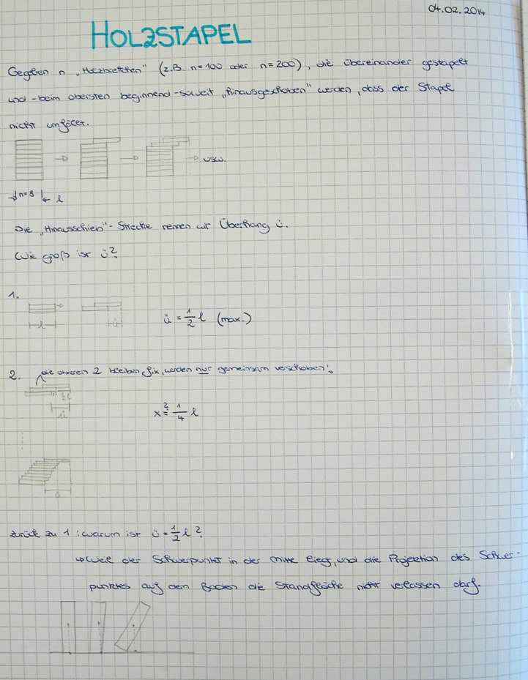

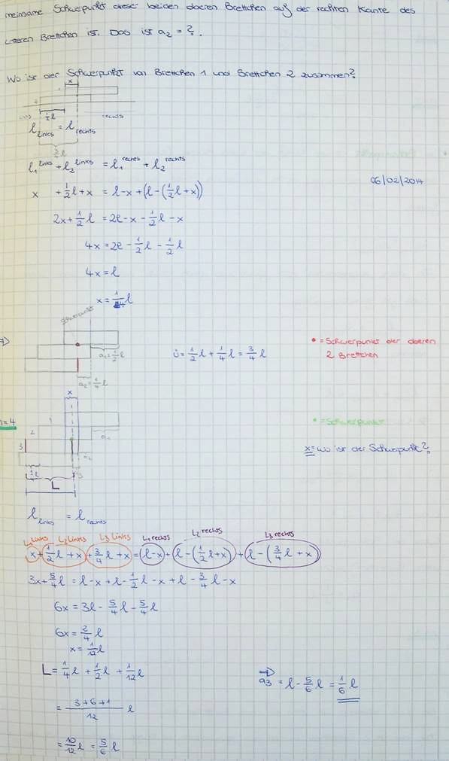

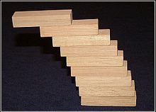
Wood Stack – Where is the Limit?

https://de.wikipedia.org/wiki/Harmonische_Reihe

1 Description of the Task and First Experiments

Take two equal wooden cuboids (dominoes or CD-covers) of length l, width b, and height h (with h a lot smaller than l and b), stack them on top of each other and move the cuboid on top so far in longitudinal direction that it sticks out as far as possible. Put a third equal cuboid underneath the two first ones and move the two upper cuboids again as far as possible. Continue this process.

2 Calculation

Consider with pen, paper, pocket calculator, etc., how far you can move the cuboids successively if the total number of blocks is$n=2, n=3, n=4, n=5, …$? How far is the total shift distance s in each case?

3 How far?

Which is the number $n_{max}$ of wooden blocks, with which a stack of this manner can be built that does not collapse?

4 With Help from the Computer

Calculate $n_{max}$ with a spreadsheet program.

5 Further Considerations

How big is s, if each cuboid is moved by l/3 or l/4?
What would happen with wooden disks?
What would change if you were allowed to use counterweights or any other additions?

Read the following articles:

Pöppe, C. (2010): Türme aus Bauklötzen – Mathematische Unterhaltungen, Spektrum der Wissenschaft, September 2010, S. 64
Paterson, M., Peres, Y., Thorup, M., Winkler, P., Zwick, U. (2008): Maximum Overhang, arXiv.org, Cornell University Library, http://arxiv.org/pdf/0707.0093v1.pdf

