

**Random Experiments**

**Investigating Probability**

Maximilian Gartner, Walther Unterleitner, Manfred Piok

**Intention**

In this learning environment, different random experiments will be tested with dice and coins to enable the pupils to become familiar with the term probability in both single-step experiments and compound experiments. The pupils should recognize the connection between statistical probability and traditional probability and be familiar with the expected value and the effects of random fluctuations. About six lessons are recommended for this learning environment.

**Background of Subject Matter**

In the lesson, the following topics will be covered:

* Statistical probability
* Presentation and distribution of values in random experiments
* Chances and probability of success
* Computer based simulation of random experiments
* Random fluctuation

**Methodical Advice**

The pupils will work together in groups of two to three in order to solve the tasks. The solutions will then be presented and discussed in class.

The Excel documents can be downloaded at: www.KeyCoMath.eu

The pupils can otherwise develop these themselves in cooperation with the teacher for computer science. As a result, more lessons will be required to complete the tasks.

**Practical Experience from Lessons**

**Is the Die Marked?**

The pupils noticed that it is possible to throw three sixes in a row. Some argue with numerical probability, others with their own experience or special throwing techniques.

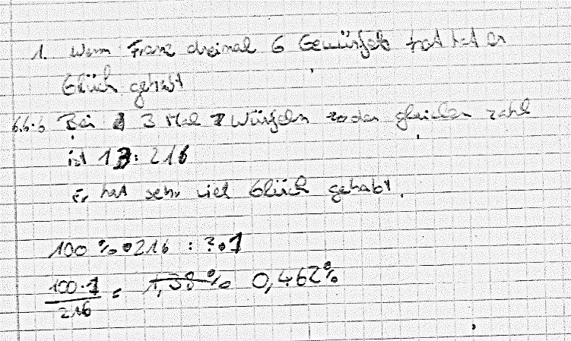

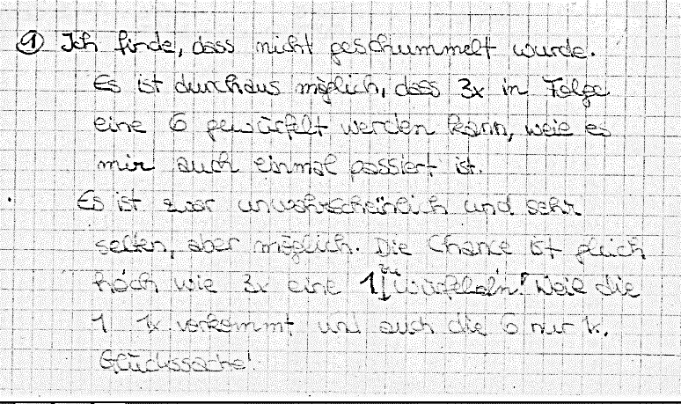

**Two Time Throw**

**Flipping a Coin:** Most of the pupils are able to name the four possible outcomes. However not all know that all four events are equal in probability.

**Throwing the Dice:** The argumentations about throwing the dice twice are quite different. Most of the pupils acknowledge that the probability of a six in one throw is $\frac{1}{6}$ . Some can even translate this to two throws.

Many pupils have problems with giving valid estimations. The pupils discuss their estimations about the 600 throws with two dice in groups of four to five. Some groups argue with their experience from the previous experiments, other groups argue with probability in general.

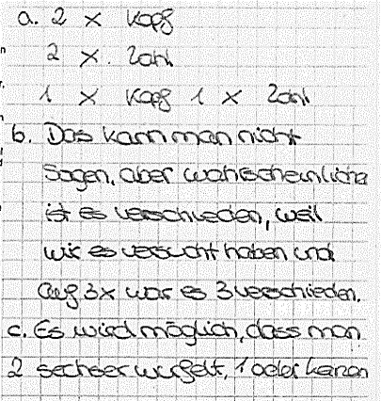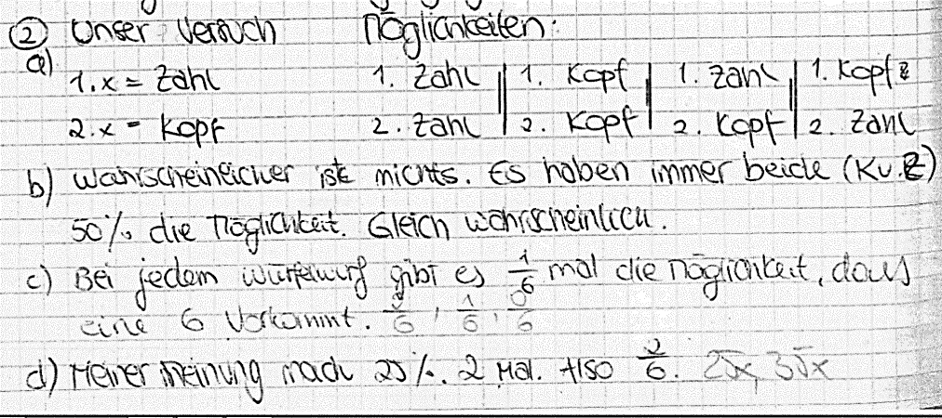

**Throwing Two Dice**

The question about a fair game is answered very differently.



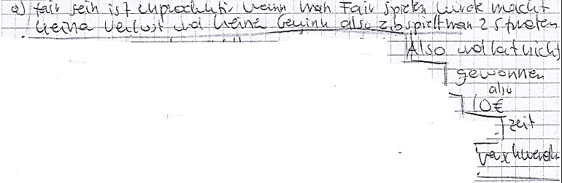

The question whether this game was fair war answered mostly empirically.



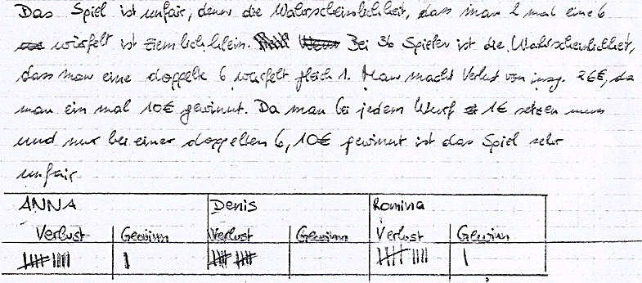

**Developing Game Variants**

The variants were very different both in completeness and complexity.

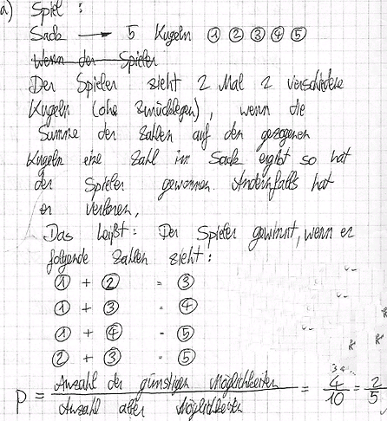

**Performance Rating**

The developed material will be handed in together with the work and will be used in rating the performance.

**Random Experiments**

**1 Is the Die Marked?**

While playing “Mensch ärgere Dich nicht“, Franz has thrown three sixes in a row. Peter is annoyed and claims that Franz has used a marked die. What do you think about this? Argue.

**2 Two Time Throw**

**Flipping a Coin**

A coin is flipped twice. It is being noted down which side is up. Try to describe all possible outcomes. Which outcome do you think is more probable: Twice the same side or two different sides?

**Throwing the Dice**

A die is thrown twice. How would you estimate the chances of throwing a certain number of sixes? Argue.

Run the experiment with the two dice 50 times and report your outcome to the teacher. Has your opinion changed or was it confirmed?

The “Throwing the Dice“-Experiment is being run 600 times. Estimate, how often the following events occur:

A: Six in the first throw.

B: No six in the first throw.

C: Six in the second throw.

D: Six in both throws.

E: At least one six is thrown.

Think of at least two more events and estimate their occurrence.

Copy the tree diagram below into your exercise book and label the different events with their empirical probability.

**Throwing a Lego Brick**

A square Lego brick is thrown once. Determine the probability of the following events:

A: The brick falls onto the base.

B: The brick falls onto a side.

C: The brick falls onto the side with the nubs.

Argue your claims.

**3 Sum of the Dice – Simulation with Excel**

Two dice are thrown.

Which sums of the dice (sums of the number of points) are possible and which sums do you think are very likely and which less likely? Argue your claim.

Give the probabilities of the different sums of dice.

It is possible to simulate this experiment with Excel. Open the file „Random_Experiments.xlsx“.   
Using „F9“ you can throw two dice 500 times.

(Possibly, iterations have to be activated in the Excel options for formulae.)

Run this experiment 30 times in order to have 15000 throws. Compare the result with your estimation. What do you notice?

**4 Throwing Two Dice**

You play against a bank:

* Bet: 1 €
* A die is thrown twice. If two sixes are thrown, the player wins 10 €.

Think about if this is a fair game. At first, discuss with your neighbour what a “fair game“ might be. Play the game 20 times with your neighbour. Note down the throws and the prizes.

Collect all outcomes in class and calculate the average prize.

**5 Developing Game Variants**

Vary the game in task 4.

Possible variations:

* Bets and prize money
* Conditions for winning
* Flipping a coin instead of throwing the dice
* Number of throws

Hand in two of your developed games with an analysis of their profitability.