Measuring Distance and Height

Functioning of Apps

Marion Zöggeler, Hubert Brugger, Karin Höller

Intention

Smartphones and tablet computers offer a variety of apps which are often based on mathematical calculations. This is the case with the measuring of distance and height. The following task is supposed to encourage the pupils to question these technical gadgets.

For this topic approximately 1-2 lessons are recommended.

Background of Subject Matter

In order to fulfill the task, basic knowledge in trigonometry is required.

Methodical Advice

This task is designed for groups consisting of two to three pupils. Great importance is attached to the documentation of the pupils’ works and the description of their approaches. The following questions are supposed to steer this documentation.
For this experimental task, a sufficient amount of smartphones or tablet computers have to be at hand. Additionally, tapes for measuring, rulers, protractors, and cords should be within reach.

Pupil’s Example

A pupil’s example concerning “small distances (1 - 50 m)“ on the worksheet:

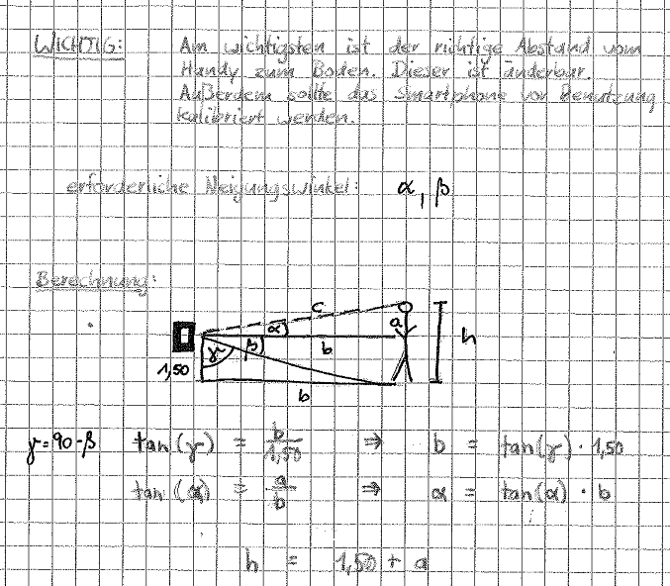

Performance Rating

Each pupil’s solution contains a sketch that shows which quantities are given or are being measured. The missing quantities are calculated through the application of trigonometric relations. The performance rating takes these two aspects into consideration. The process of measuring itself or the search for additional information (e.g. in the app’s user manual) should also contribute to the final rating.

Measuring Distance and Height

Functioning of Apps

Smartphones and tablet computers offer a variety of apps which make use of mathematical calculations. An example is the measuring of distance and height.

Small Distances (1 - 50 m)

Taken from the “Smart Measure Lite“-Manual:
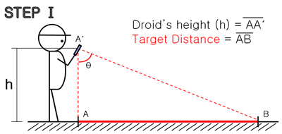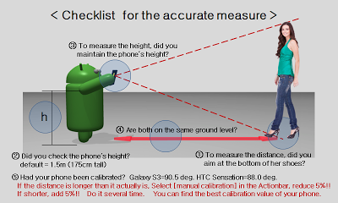

- The measured length is for reference.

- Before using this App, calibrate your devices with known distances.

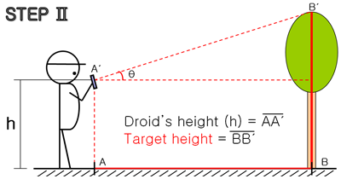
- If the measured distance is longer than it, reduce by 5% at manual calibration. If shorter, increase by 5%. Do it several times. You can find your own best calibration.

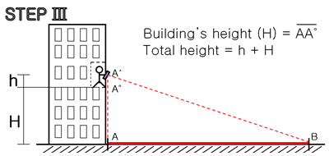

© Smart Tool co
Shown above are the instructions for the app “Smart Measure“.

Measure some distances and heights with your smartphone or tablet PC and check the results with a tape measure. Compare.

Now we want to take a closer look at the app:

- Which quantities are necessary for the app?
- The device can measure angles of inclination. Which angles of inclination are necessary for calculating the distance and height of an object?
- By which means are distance and height calculated?
- Draw a sketch, measure the required quantities with a tape measure and calculate the distance and height yourself using trigonometry.

