

**Illustrative Limits**

Johannes Schönberger

**Intention and Aims**

This learning environment is supposed to illustrate the rather complex concept of limits. In this lesson (90min) the pupils should become motivated to explore this aspect of functions. The legend brings mathematics, physics and history together and the paradox ought to enhance the pupils’ interest. Furthermore the understanding of infinity is improved.

**Background Knowledge**

The pupils are already familiar with polynomials and simple rational and trigonometric functions. Additionally, they have carried out simple limit considerations in power functions.

**Methodical Advice**

The lesson is organised as a combination of individual and group work. Each pupil receives a work sheet with seven tasks. The number of smileys indicates, how many pupils are supposed work together in order to solve a problem.The teacher only assists if necessary. The pupils who have finished the first worksheet receive a second one which should be solved in the same manner. If pupils finish both worksheets before the end of the lesson, they should be told to think about and discuss the equation $0,\overline{9}=1$. At the end of the lesson, the teacher hands out a sample solution. As a result of this, slower-working students are given the chance to solve the problems on their own at home and check their solutions.

**Racing Achilles**

The greek hero Achilles, who was known for his speed, races you. Achilles grants you a lead of 1km. Now the two of you start the race at the same time. When Achilles has reached your starting position after one kilometer, you have run 0.5km. When Achilles has run these 0.5km, you have mastered another 0.25km. This will continue analogically. Thus, Achilles will never catch up with you! Or not?

1. How much faster than you is Achilles?

Achilles runs __ times as fast as you.

1. Continue the graph and label the axes. What do you notice?
2. How far does Achilles have to run in order to catch up with you? (Write with “…“)

$s=1km+\frac{1 }{2 }km+\frac{ }{ }km+\frac{ }{ }km+…$

*Infinite sum (=series)*

1. Try to specify the distance! (Hint: Calculate $s-\frac{1}{2}s$)

*The infinite sum therefore has a/an*

* *finite*
* *infinite*

*limit s.*

$⇒ s= km$

1. How much time does he need to catch up with you?
$$t=$$

2. Which wrong conclusion did Zenon of Elea (~450 B.C.), the author of this legend, draw?
3. How could you have determined the limit of the series above with this picture?

$If the function values f\left(x\right) approach a number a for x→+∞ or x→-∞,$

$$a is called limit of the function.$$

$$\lim_{x→+∞}{f\left(x\right)}=a or\lim_{x→-∞}{f\left(x\right)}=a$$

For $a∈R$, $f$ is called **convergent**.

For $a=+∞$ or $a=-∞$, $f$ is called **divergent with an infinite limit**.

If no $a$ exists in this manner, $f$ is called **divergent**.

1. 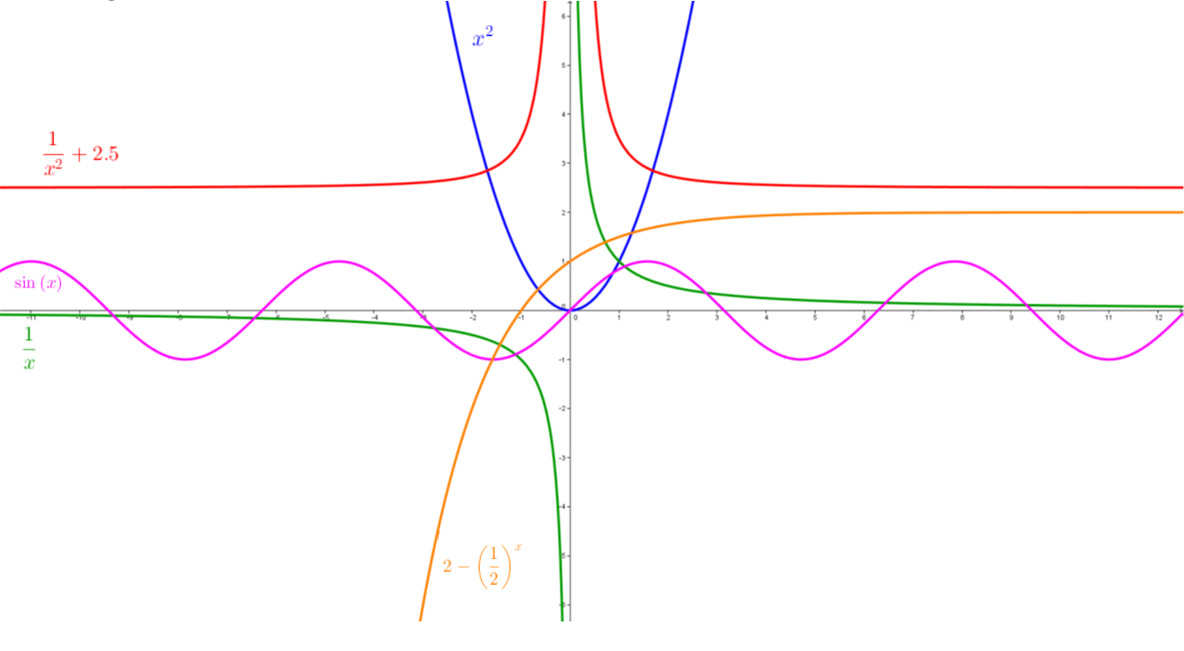Make an educated guess about the limits of these functions for $x→+∞$ and $x→-∞$.
2. Think about how it is possible to determine the limit of the functions above just with the help of the functional equations. Test your solution with the following functions: $f\left(x\right)=\frac{x+1}{x-2}$ and $g\left(x\right)=\frac{x²+1}{x-2}$.
3. Find a function which converges for $x→-∞$ with the limit +107 and diverges for $x→+∞$ with an infinite limit.