Lengths of Days over the Course of the Year

Modelling with the Sine Function

Julian Eichbichler

Intention

In this learning environment, the pupils should not only become acquainted with the course of the trigonometric functions but also learn about the influence of parameters on amplitude, period duration and phase shift. This is achieved through the use of explicit examples. After this, the motions of the moon in relation to the earth can be taken a look at: How are the seasons created? How does the length of day change over the course of the year when I am at North or South Pole? Which day is the longest/shortest? Why?

Background of Subject Matter

The change in the length of day of the home town should be presented graphically and be approximated with an adequate curve (regression model). This function will be analyzed in different tasks. Through this, the pupils are acquainted with the general sine function and learn about the influence of the different parameters. Furthermore, they should be enabled to understand and question phenomena in daily life. For this topic, about four lessons are recommended.

The pupils should already be familiar with the trigonometric functions on the unit circle. Thus, they should have knowledge of the function $f\left(x\right)=\sin{x}$ and its co-domain, graph and periodicity.

The task “Identify the change in the length of day over the course of the year“ is not immediately connected to trigonometric functions by the pupil. This is only possible through the regression model. As a result, the pupils become familiar with the significance of the parameters in the function term of the general sine function$f\left(x\right)=a∙\sin\left(bx+c\right)+d$.

Methodical Advice

On the website
http://aa.usno.navy.mil/data/docs/RS_OneYear.php
it is possible to calculate the exact time of sunrise and sunset for the home towns of the pupils.

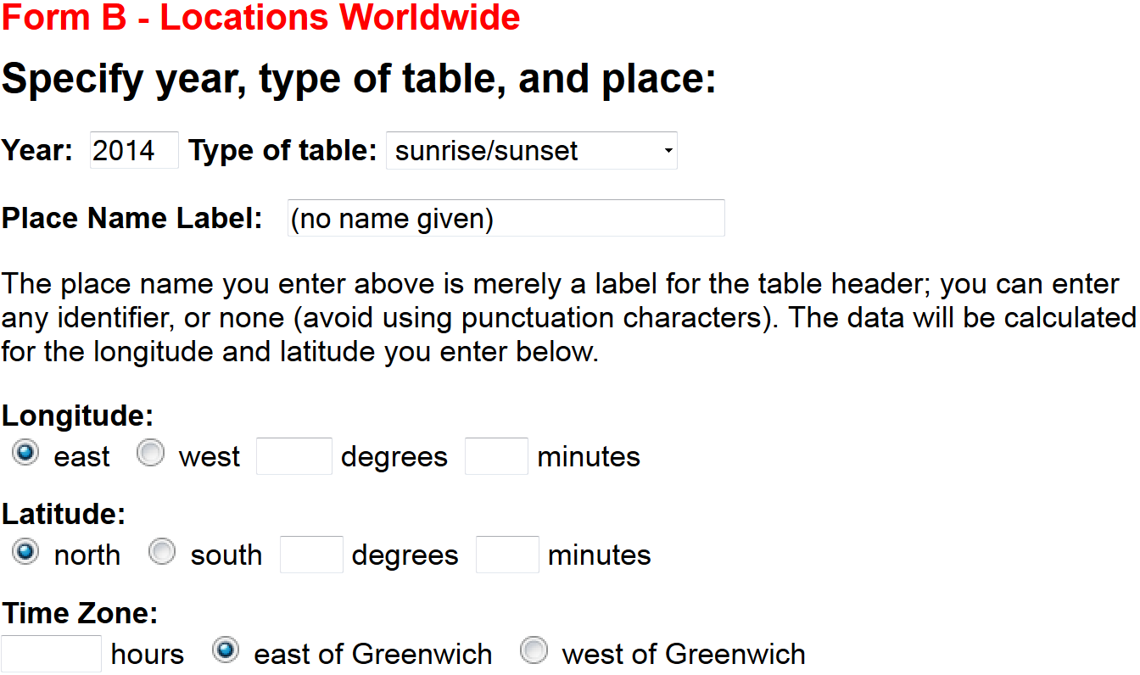

Firstly, the longitude and latitude of the home town have to be discovered. Furthermore, the time zone has to be identified and its influence explained.

On the website, there are instructions about the import of collected data to Excel.

In class, the following graphs were found:

It is only possible in GeoGebra to approximate the discovered curve with the sine function as the necessary tools do not exist in Excel.

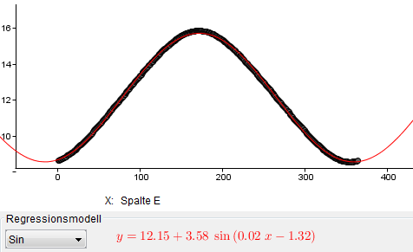

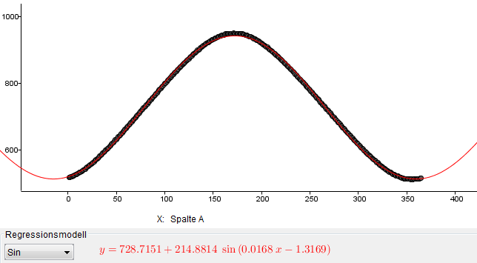

With the help of the approximated function$f\left(x\right)=a∙\sin\left(bx+c\right)+d$, the data can be analyzed:

Average length of day: $d=728,7 \text{min}=12 \text{h} 9 \text{min}$

Difference longest – shortest day: $2a=429,8 \text{min}=7 \text{h} 10 \text{min}$

Period duration: $T= \frac{2π}{b}=374$ Days (Problem: rounding errors)

Phase shift: $φ= \frac{c}{b}=78,4$ Days

Thus, the 18th of December is the minimum or shortest day.

Comparison with actual results:

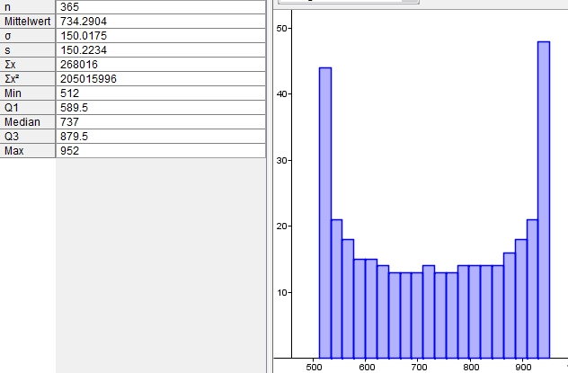

It is necessary to explicitly name the website on which the data should be collected as some cities have already put graphs on the length of day online. However, especially the analysis of data is difficult for the pupils.

Performance Rating

Especially important are the completeness of the required report and the logic of the argumentation. In the next exam it is possible to ask a question about the project (e.g. which function describes the change of the length of day over the course of a year? Explain).

Further Considerations

After the end of the project, the general sine function should be analyzed systematically.

- Investigate the influence of the parameters $a$, $b$, $c,$ and $d$ on the graph of the function
$f\left(x\right)=a∙\sin\left(bx+c\right)+d$.

Example: Take a close look at the graphs of$\sin\left(x\right)$, $\sin{(2x)}$, $\sin{(3x)}$, $\sin\left(0,5x\right)$, $\sin{(0,2x)}$.
Which changes does the parameter generate in the graph of the function?

- Write a clear report about your observations.

- Find adequate terms for the significance of the parameters.

Identify the Lengths of Days over the Course of the Year in Your Home Town!

In the following, you can look at the change in the lengths of days over the course of the year in your home town. After that, you will be able to present your results graphically and approximate them with a suitable curve (regression model).

As a basis, you use data collected on the internet. It is your decision, which programs you would like to use in order to process and analyze the data.

1 Collect Data

Find information about the exact time of sunrise and sunset in your home town on this site:
http://aa.usno.navy.mil/data/docs/RS_OneYear.php

2 Analyse Data

Analyse the collected data:

- How long is an average day?

- By how many minutes differ the longest and the shortest day?

- Calculate the change in the lengths of days per day in minutes. Why does the change in some periods of time happen more rapidly than in others?

- How do the lengths of days change over the course of the year at the North Pole?

- If a day is longer at the North Pole than it is here, the temperature there should in comparison be higher! Argue.

- Are your data and results realistic?

3 Appendix

The sun is not punctiform, so why should the solar day be defined?

Does the sun really rise in the east? … Think of different places on earth.

4 Basis for Evaluation

Write a well-structured report about your observations and find logical terms for the different quantities.

