Which Shape is best for a Honeycomb Cell?

Optimisation Tasks

Marion Zöggeler, Hubert Brugger, Karin Höller

Intention

This learning environment is focused on the optimal shape of a honeycomb cell. This is an illustrative, interdisciplinary example of an optimization task. If the task is used in lower class levels, the focus is placed on the qualitative description of functions and the experimental approach at finding solutions. In higher class levels this learning environment can be used to work with differential equations of one or multiple variables.

A minimum of four lessons are recommended for this learning environment.

Background of Subject Matter

The tasks are supposed to guide the pupils to the optimal honeycomb cell. The first tasks are more simple tasks in the plane which have to be translated into the three dimensional space.

Here are a few suggested solutions:

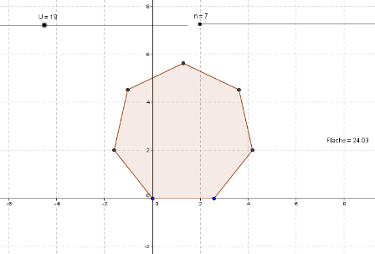
For 1 Maximal Area

In GeoGebra, the different polygons with given perimeter are constructed and their areas are calculated. Here it can be seen that the area converges with an increase in vertices. The limit is the area of a circle.

The GeoGebra file can be downloaded at
www.KeyCoMath.eu.

Areas of Regular Polygons in a Circle

In Excel, a tabular overview of the areas of different polygons can be created.

Example of a circle radius of 10cm:

Number of vertices n | Central angle in degree measure | Central angle in radian measure | Area of the n-gon in cm²
3 | 120,00 | 2,094395102 | 129,9038106
4 | 90,00 | 1,570796327 | 200,0000000
5 | 72,00 | 1,256637061 | 237,7641291
6 | 60,00 | 1,047197551 | 259,8076211
7 | 51,43 | 0,897597901 | 273,6410189
8 | 45,00 | 0,785398163 | 282,8427125
9 | 40,00 | 0,698131701 | 289,2544244
10 | 36,00 | 0,628318531 | 293,8926261
20 | 18,00 | 0,314159265 | 309,0169944
30 | 12,00 | 0,209439510 | 311,8675362
40 | 9,00 | 0,157079633 | 312,8689301
50 | 7,20 | 0,125663706 | 313,3330839
60 | 6,00 | 0,104719755 | 313,5853898
70 | 5,14 | 0,089759790 | 313,7375812
80 | 4,50 | 0,078539816 | 313,8363829
90 | 4,00 | 0,069813170 | 313,9041318
100 | 3,60 | 0,062831853 | 313,9525976
150 | 2,40 | 0,041887902 | 314,0674030
200 | 1,80 | 0,031415927 | 314,1075908
250 | 1,44 | 0,025132741 | 314,1261930
300 | 1,20 | 0,020943951 | 314,1362983
350 | 1,03 | 0,017951958 | 314,1423915
400 | 0,90 | 0,015707963 | 314,1463462
450 | 0,80 | 0,013962634 | 314,1490576
500 | 0,72 | 0,012566371 | 314,1509971

Result: The area of the polygon is approximated by the area of a circle.

The Excel file can be downloaded at www.KeyCoMath.eu.

For higher class levels, a calculation of the limit may be adequate:
$$\lim_{n→∞}{n∙\frac{r^{2}}{2}∙\sin\left(\frac{2π}{n}\right) } = \lim_{x→0}{2π∙\frac{r²}{2}}∙\frac{sinx}{x} = r²π$$

Here, the substitution $\frac{2π}{n}=x$ and the limit $\lim_{x→0}{\frac{sinx}{x}}=1$ have been used.

For 2 Special Case: Rectangle

Here, a rectangle with given perimeter is to be considered: In which manner do the sides $a$ and $b$ have to be chosen in order to generate a maximal area?

This problem leads to the minimum of a quadratic function. A pupil’s suggested solution:

For 3 The Other Way Round: Minimal Perimeter

In this task the perimeter of a rectangle $P\left(a\right)=2\left(a+ \frac{A}{a}\right)$ with a given area A should be examined in relation to a side length $a$. Again, a minimum ought to be found. In this case, a graphical representation can be helpful. In higher class levels, differentiate equations will be used. A pupil’s suggested solution:

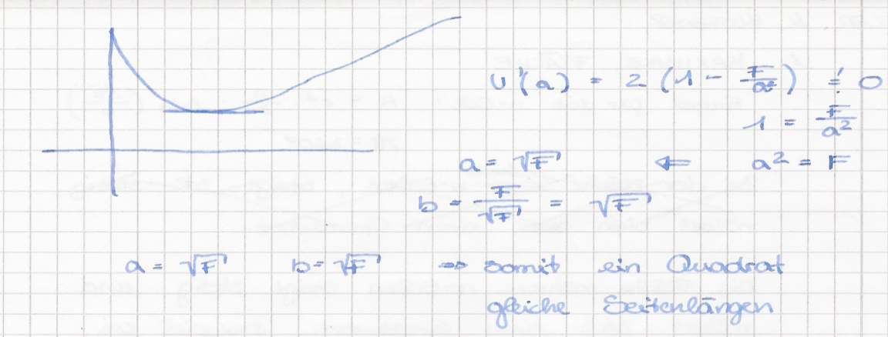

For 4 Special Case: Triangle

With Heron’s formula $A= \sqrt{s\left(s-a\right)\left(s-b\right)\left(s-c\right)}$ , the area of a triangle with given perimeter can be expressed with two variables. Here$s=\frac{P}{2}=\frac{a+b+c}{2}$.
Experimental solutions can be found with Excel or GeoGebra. Exact solutions require the use of methods from mathematical analysis in two variables.
A pupil’s suggested solution:

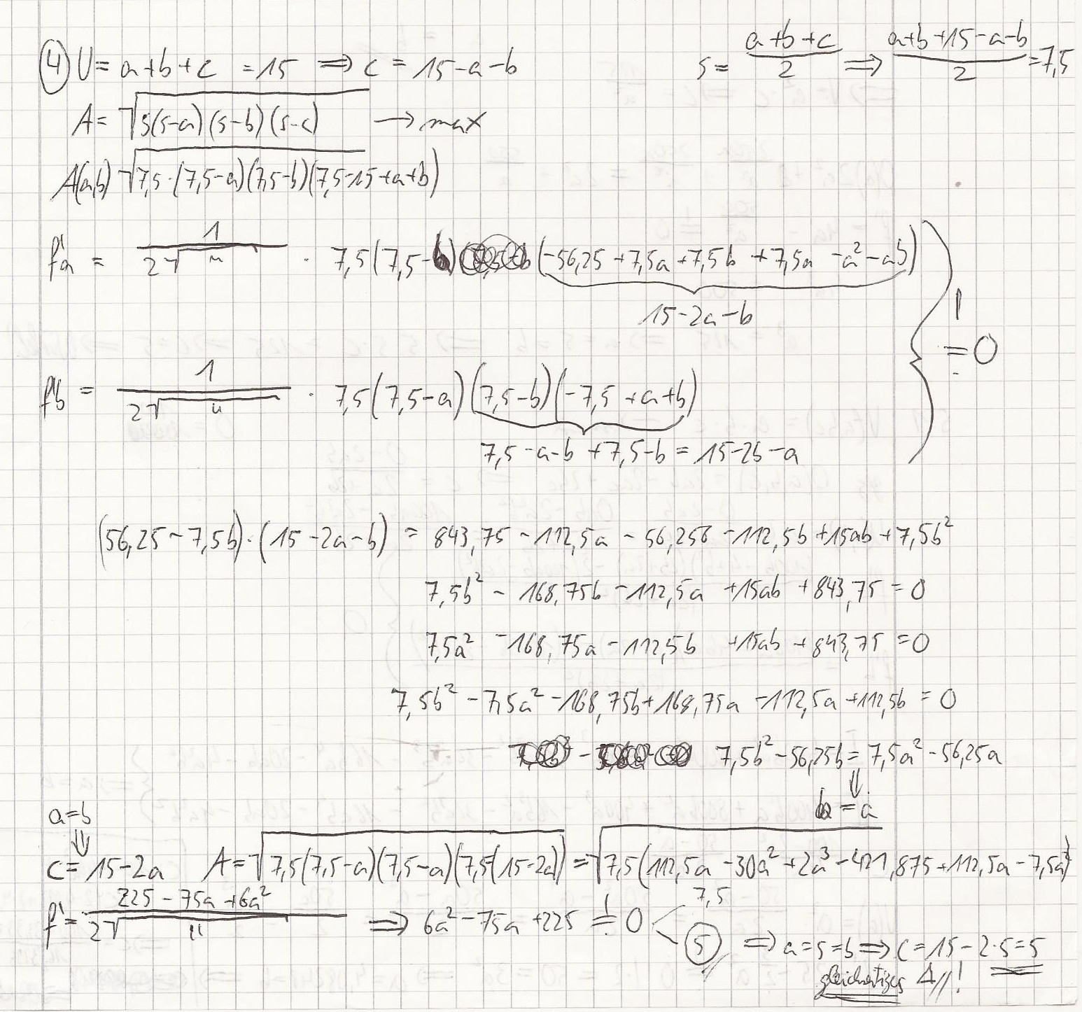

For 5 From Plane to Space

In this task terms have to be translated from the plane to the three dimensional space.
- Perimeter equals surface area
- Area equals volume
- Rectangle equals cuboid
- Square equals cube

All pupils should be able to do this. Finding optimal solutions in three dimensional space, however, will be especially interesting for motivated pupils.

Example: Consider a cuboid with given surface area and determine the sides$a$, $b$ and $c$ in the manner that the result is the maximal volume.
A pupil’s suggested solution:

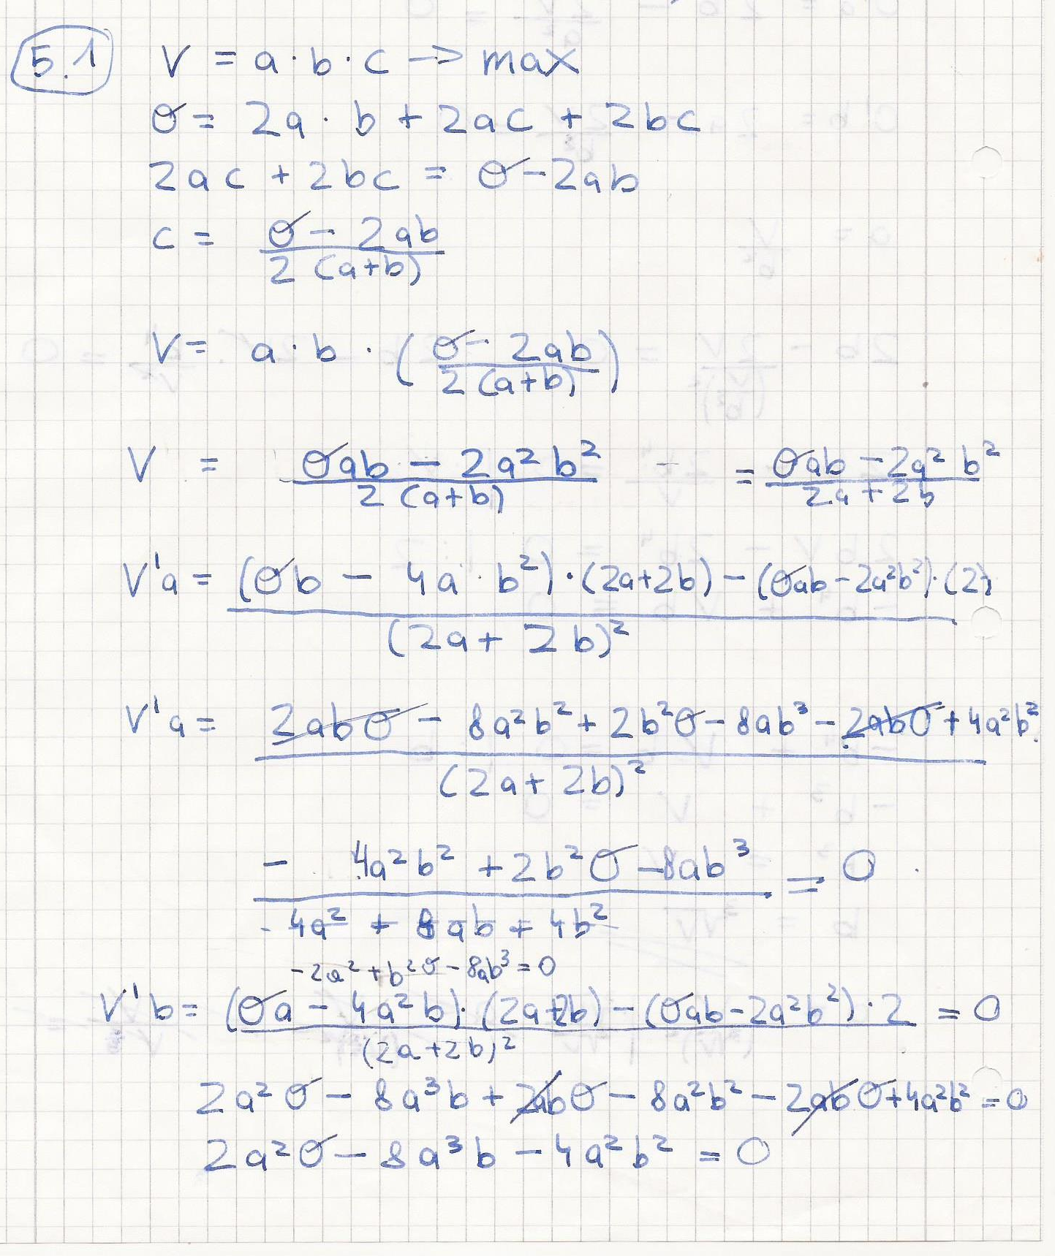
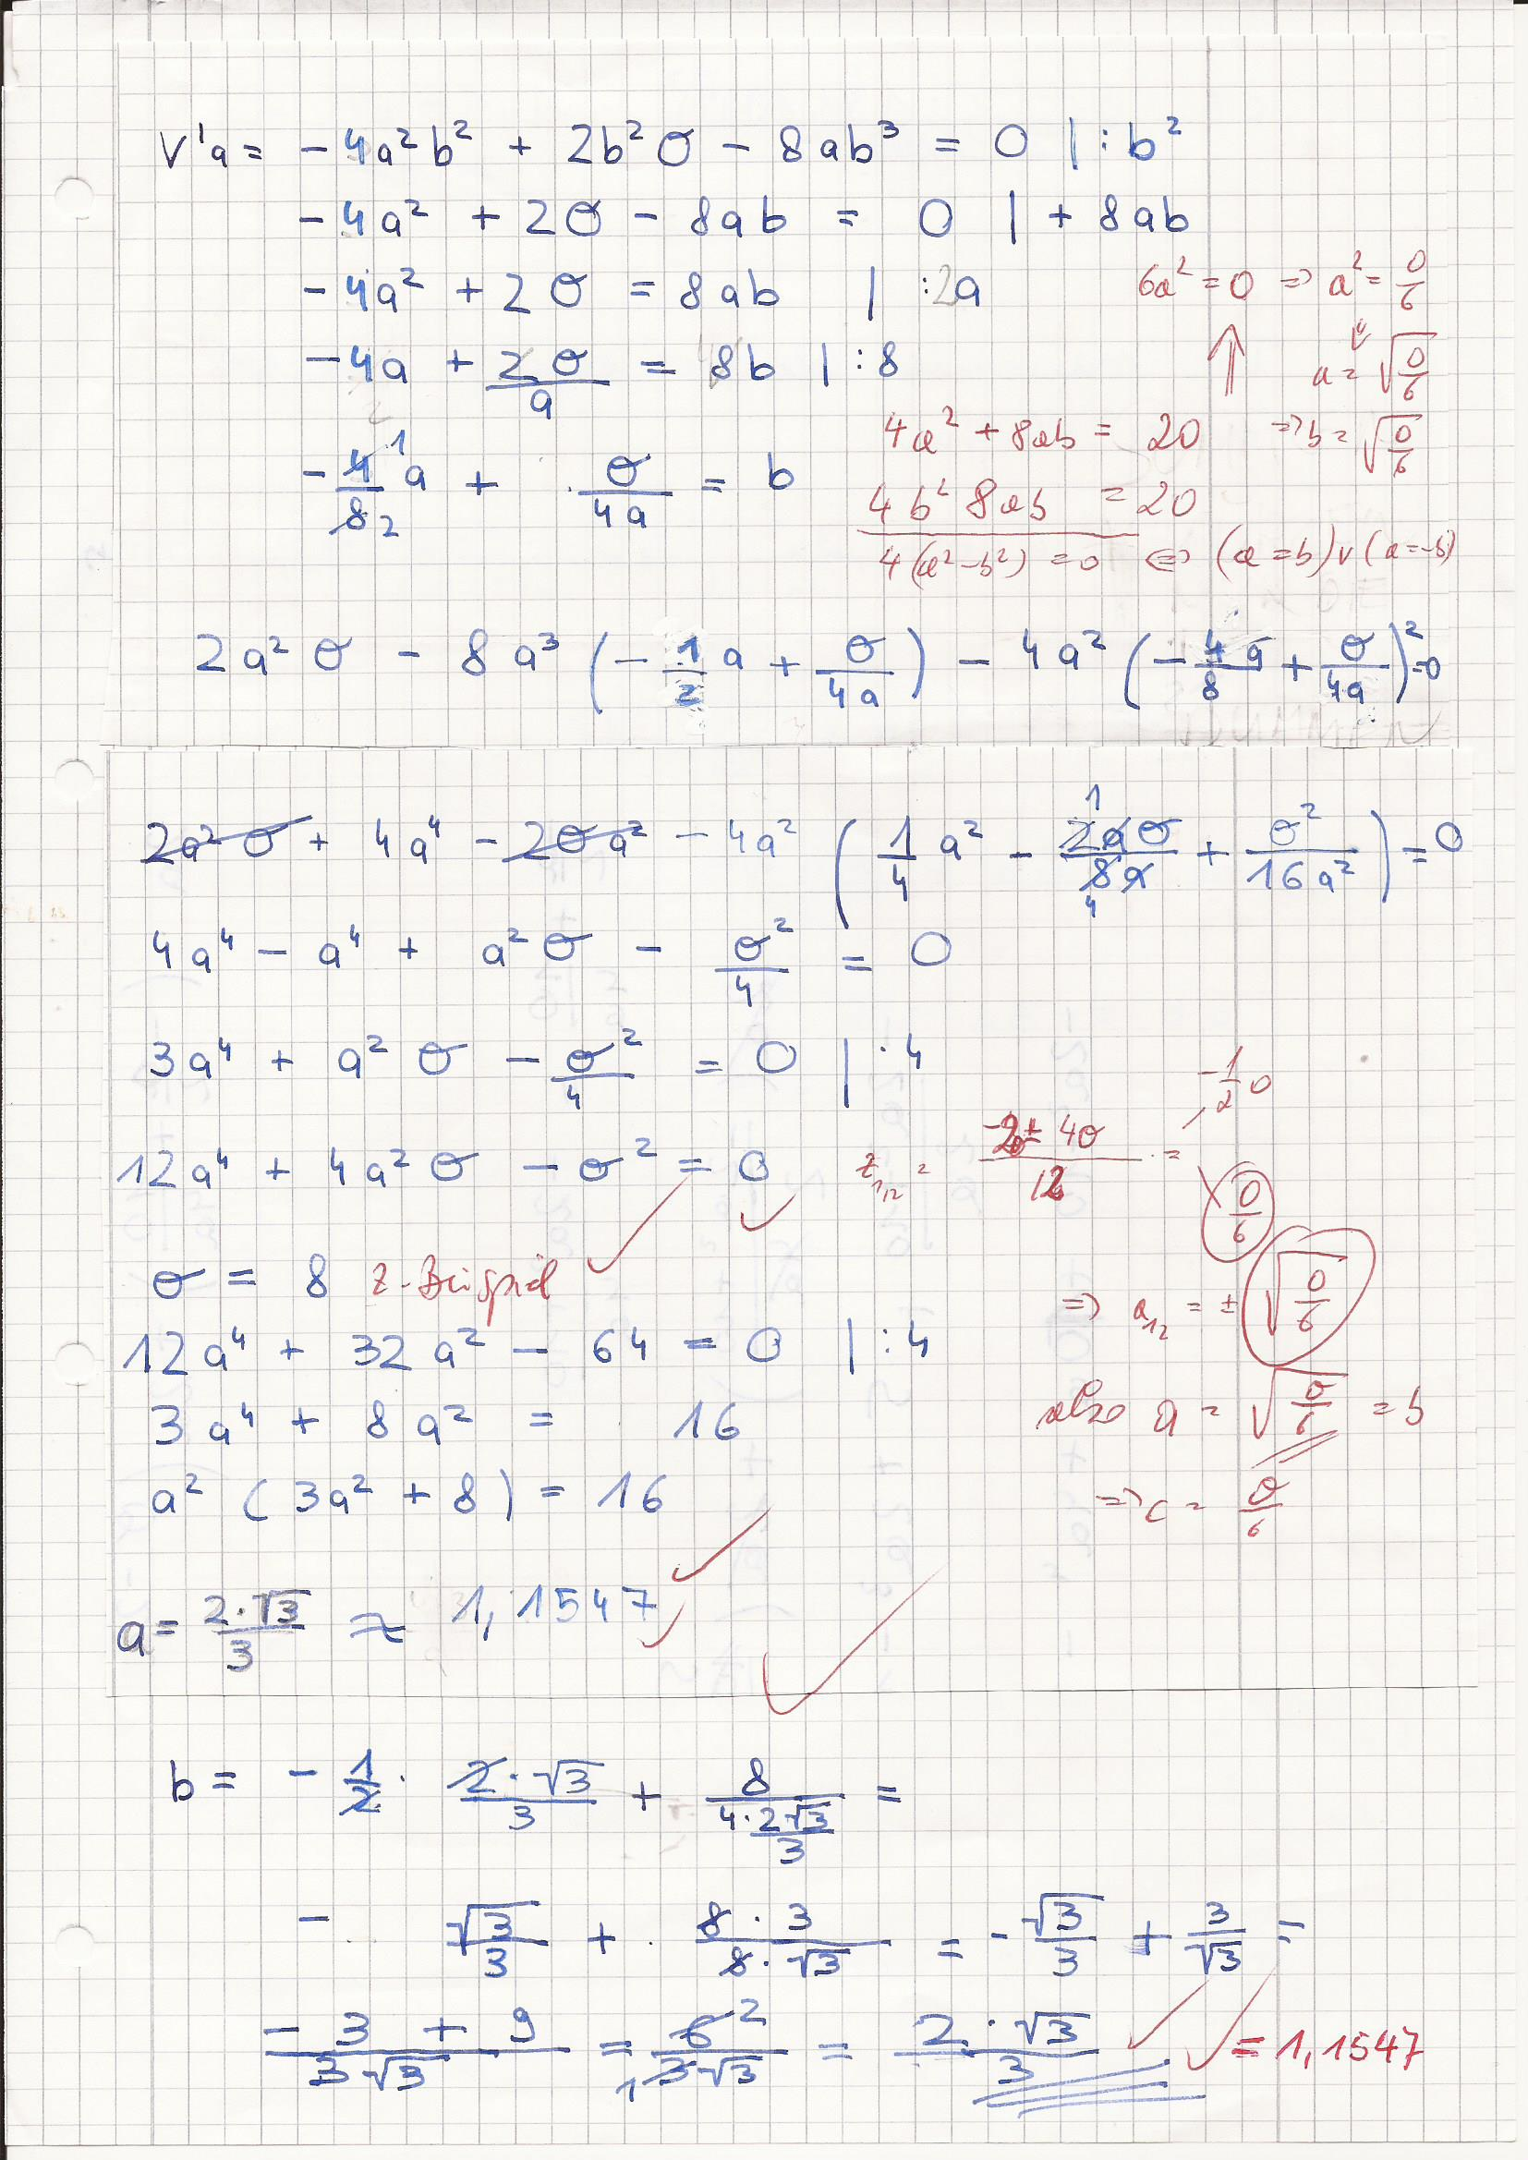
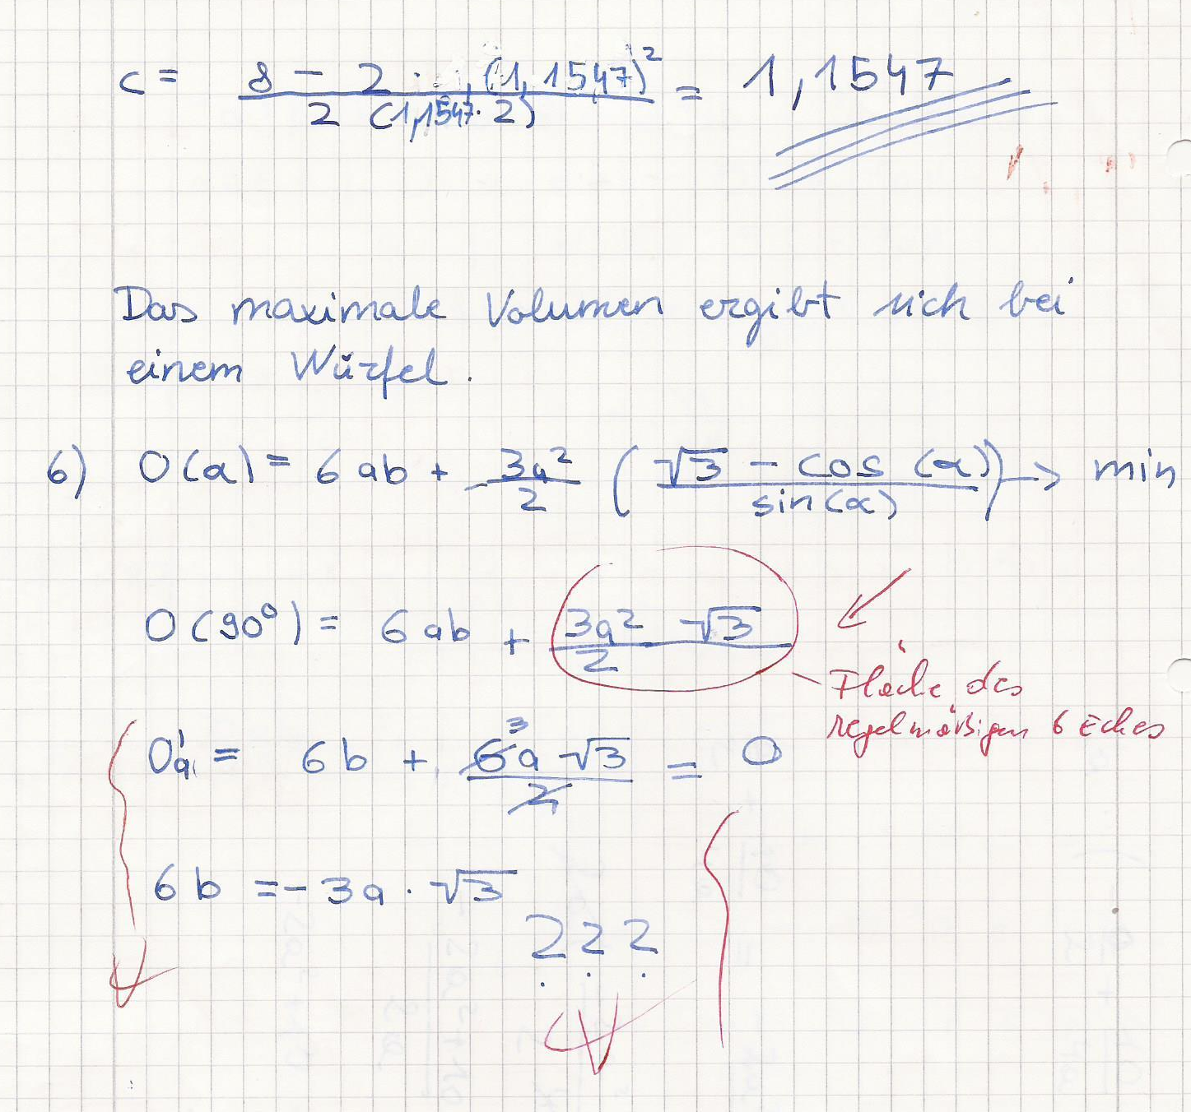

Example: Consider a cuboid with given volume and determine the sides $a$, $b$and $c$ in the manner that the result is a surface area which is as small as possible.
A pupil’s suggested solution:

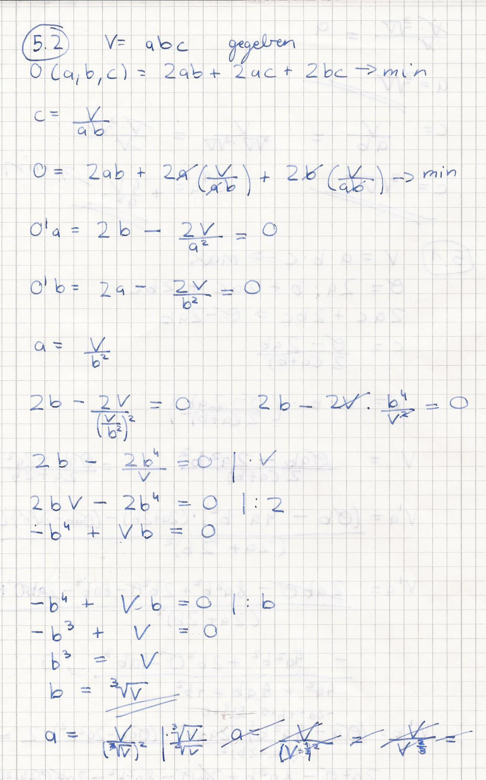

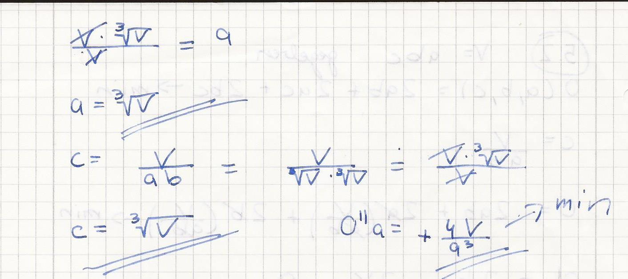

For 6 Optimal Shape of a Honeycomb Cell – Hexagonal Base

Pupils should show that the plane can only be completely covered by triangles, squares or regular hexagons. At each vertex of a polygon in the plane at least three other polygons meet. The sum of the neighbouring interior angles is 360°. For an interior angle of a regular n-gon, it is valid that:
$$α=\frac{\left(n-2\right)∙180°}{n}$$

This has to be a divisor of 360°, which is only valid for$n=3$, $4$ and $6$.

In order to find the minimal perimeter of the polygon, results from task 1 can be used.

For 7 Optimal Shape of a Honeycomb Cell – Optimal Inclination Angle

The pupils can build a model of a honeycomb cell out of paper. This increases the understanding of the situation. Instructions can be found at:
http://www.friedrich-verlag.de/go/doc/doc_download.cfm?863A9A4813DE4E43ACC8C085D8AD7222

This task can only be used in higher class levels as differential equations are needed.

Methodical Advice

It makes sense to solve the tasks together with a partner or in groups. After this, the suggested solutions can be discussed in class.

Performance Rating

The performance rating can be based on the drawing up of the models, the work on the computer, the presentation of the results, and the way of working.

Bibliography

Schlieker, V., Weyers, W. (2002): Bienen bauen besser, in: mathematik lehren, Heft 111, Friedrich Verlag
Dietrich, V., Winter, M, Hrsg. (2003): Architektur des Lebens, Mathematische Anwendungen in Biologie, Chemie, Physik, Cornelsen Volk und Wissen Verlag
Steiner, G., Wilharter, J. (2007): Mathematik und ihre Anwendungen in der Wirtschaft 3, Reniets Verlag

Optimization task: Which is the Best Shape for a Honeycomb Cell?

In nature, building styles have improved through evolution and are now almost optimal – for instance the building of a honeycomb cell. But what is optimal in this context?

Solve these tasks in order to answer the question:

1 Maximal Area

Given is a piece of rope of a certain length. How can you enclose an area which is as large as possible? Try different geometric shapes. Document your results.

Which is the most adequate shape? Argue your assumption. Use Excel or GeoGebra to support your claim.

Hint: Formula for the area of a regular polygon: $A=n∙\frac{r^{2}}{2}∙sin\left(\frac{2π}{n}\right)$

2 Special Case: Rectangle

Choose a rectangle with given perimeter. Determine the side lengths that generate the largest area. Argue your suggested solution. Are there different approaches?

3 The Other Way Round: Minimal Perimeter

Consider a rectangle with given area. Which side lengths should it have to generate a minimal perimeter? Argue your suggested solution.

4 Special Case: Triangle

Examine any triangle with a given perimeter. How long should the side lengths be in order to create a maximal area? Argue your suggested solution by considering the area as a function with two variables.

Hint: Heron’s formula for the area of triangles:$A= \sqrt{s(s-a)(s-b)(s-c)}$, with $s=\frac{P}{2}=\frac{a+b+c}{2}$

5 From Plane to Space

Translate tasks 2 and 3 to the three dimensional space. Find optimal solutions for this as well.

6 Optimal Shape of a Honeycomb Cell – Hexagonal Base

Firstly the problem is considered in a plane. The honeycomb cells completely cover the plane.
Which polygons are adequate for this?
Hint: formula for the sum of the interior angles of a regular n-gon: $α=\frac{\left(n-2\right)∙180°}{n}$

Which of these polygons has the minimal perimeter?

Hint: Use the solution of task 1

7 Optimal Shape of a Honeycomb Cell – Optimal Inclination Angle
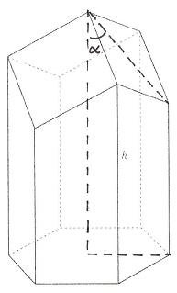
The figure shows the model of a honeycomb cell. You can see that the top is no plane hexagon. The biologist D’Arcy discovered that the surface area is just dependent of the inclination angle of the three areas forming the top of the cell. He even found a formula for this:

$$S\left(α\right)=6ab+\frac{3a^{2}}{2}\left(\frac{\sqrt{3}-cos(α)}{sin(α)}\right)$$

Here, $a$ is a side of the hexagon and b is the longer side edge.

Determine angle $α$ in the manner that it generates a minimal surface area.

